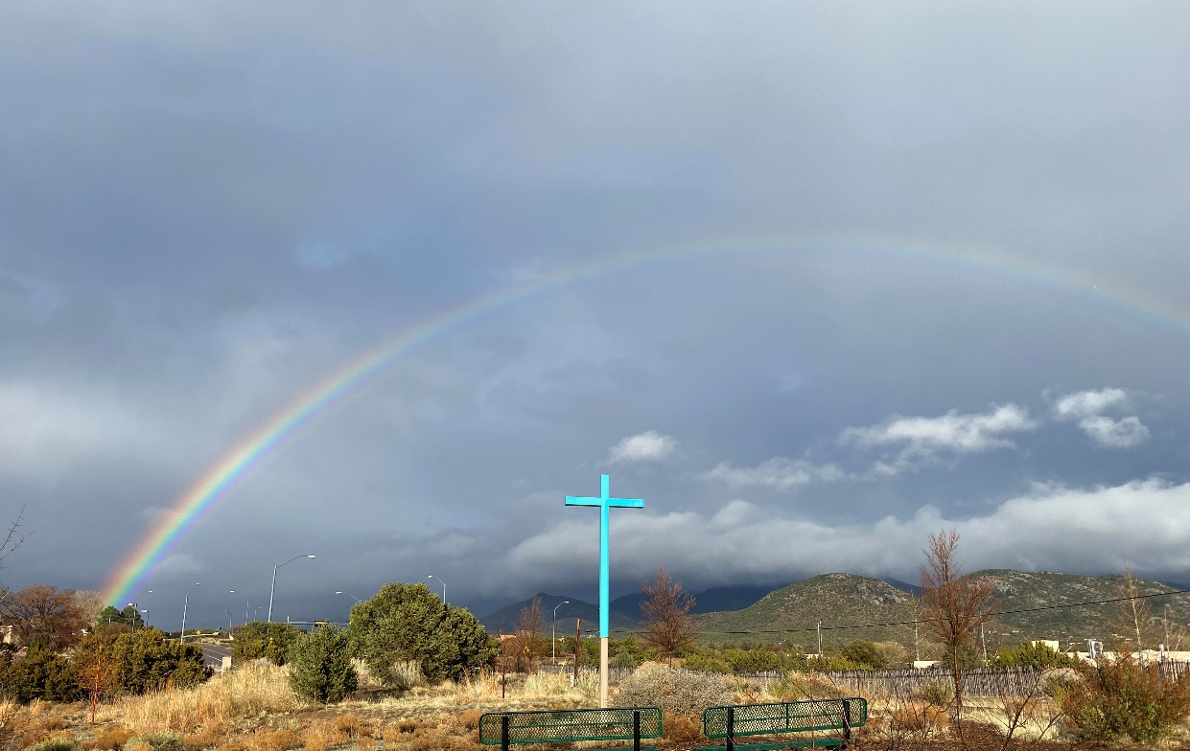

The United Church of Santa Fe

A United Church of Christ

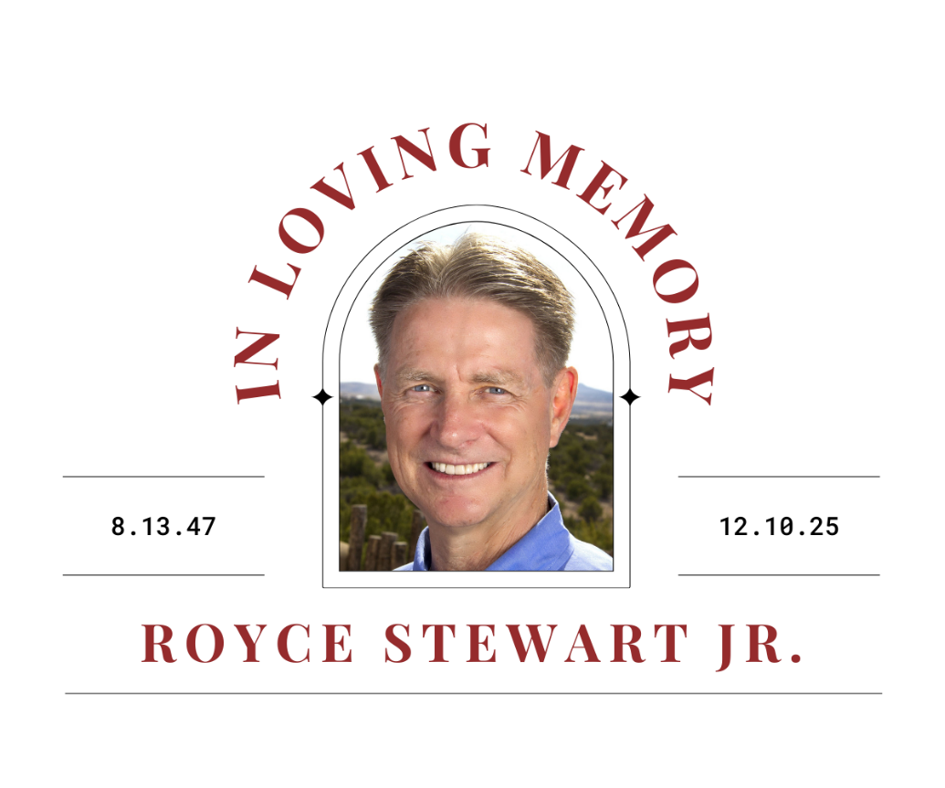

WE GATHER
(To be a spirit of prayer and worship, please turn off cell phones. Thank you.)

Gathering Music PIANO Selections from Return to the Heart David Lanz
The Setting of Two Suns
Madre de la Tierra

Welcome and Breathing in God’s Spirit TA

Prelude piano Variations on a Theme from Pachebel’s Canon in D Major David Lanz

The Promises of Faith TA Isaiah 25:6-9
Gospel of John (from ch. 14)

Breathing in God’s Spirit Again TA

The Call to Worship from Psalm 46 (congregation in bold) TA

God is our refuge and strength, a very present help in trouble.
Therefore we will not fear though the earth should change,
Though the mountains shake in the heart of the sea;
Though its waters roar and foam,
Though the mountains tremble with its tumult.
The Lord of hosts is with us; the God of Jacob and Rachel is our refuge.
Be still and know that I am God.
The Lord of hosts is with us; the God of Jacob and Rachel is our refuge.

*Hymn 451 Be Now My Vision (1-2, 4) Irish Text and Melody

(*Please rise in body or spirit.)

WE PREPARE

Words of Welcome and the Journey to this Day TA

A Prayer of Invocation and Openness to God’s Love and Strength TA

A Time of Silent Prayer

*Affirmation of Faith (unison) TA LEADS Psalm 23 (as a doxology)

You, Lord, are our shepherd, we shall never be in need.
You make us to lie down in green pastures; You lead us beside the still waters;
You restore our souls.
You lead us in the paths of righteousness for your name’s sake.
Yea, though we walk through the valley of the shadow of death,
We will fear no evil; for you are with us; Your rod and your staff they comfort us.
You prepare a table before us in the presence of our enemies;
You anoint our heads with oil; Our cup overflows.
Surely goodness and mercy shall follow us all the days of our lives;
and we will dwell in the house of the Lord forever.

Musical Affirmation Where No One Stands Alone soloist with guitar, needs mic

WE REMEMBER

Remembering God’s Promises TA INTROS AND READS PSLAM

From the Psalms Psalm 139 (cond.)

O Lord, you have searched me and known me.
You know when I sit down and when I rise up;
you discern my thoughts from afar.
You search out my path and my lying down,
and are acquainted with all my ways.
Where can I go from your Spirit?
Or where can I flee from your presence?

If I ascend to heaven, you are there;
if I make my bed in Sheol, you are there.
If I take the wings of the morning
and settle at the farthest limits of the sea,
even there your hand shall lead me,
and your right hand shall hold me fast.

From the Good News of Jesus Christ (Matthew 5:1-10) Beverly McWilliams

When Jesus saw the crowds, he went up the mountain; and after he sat down, his disciples came to him. Then he began to speak, and taught them, saying:
“Blessed are those who know their need of God, for theirs is the kingdom of heaven.
“Blessed are those who mourn, for they will be comforted.
“Blessed are the gentle, for they will inherit the earth.
“Blessed are those who hunger and thirst for righteousness, for they will be filled.
“Blessed are the merciful, for they will receive mercy.
“Blessed are the clear in heart, for they will see God.
“Blessed are the peacemakers, for they will be called children of God.
“Blessed are those who are persecuted for righteousness’ sake,
for theirs is the kingdom of heaven.”

Remembering Royce TA INTROS, followed by these reflectors, all from pulpit

Carolyn Stewart

John Richard Stewart

Kristofer Lenz
(silence)

Poem (pulpit) He is Gone by David Harkins Robert Tyron

Final Reflection Rev. Talitha Arnold

The Apostle Paul’s Letter to the United Church in Phillipi (4:8-9) TA

Finally, beloved, whatever is true, whatever is honorable, whatever is just, whatever is pure, whatever is pleasing, whatever is commendable, if there is any excellence and if there is anything worthy of praise, think about these things. Keep on doing the things you have learned and received and heard and seen in me, and the God of peace will be with you.

A Time of Silence

Musical Reflection Goin’ Home soloist with guitar)

WE RESPOND

The Prayer of Committal TA

WE GO OUT IN PEACE

*Hymn The Lord’s Prayer Albert Hay Malotte

Our Father, which art in heaven, hallowed be thy name.
Thy kingdom come. Thy will be done in earth, as it is in heaven.
Give us this day our daily bread. And forgive us our debts, as we forgive our debtors.
And lead us not into temptation; but deliver us from evil:
For thine is the kingdom, and the glory, and the power for ever and ever. Amen.

*Benediction TA

*Postlude Largo from Symphony No. 9 in E Minor Antonín Dvořák/arr. Charles Szczepanek

************

Welcome and Thank You

On behalf of Royce’s family, we thank you for being here today. Your presence is a source of comfort and strength for all of them. You are also invited to the luncheon at the Hilton Hotel in downtown Santa Fe. Again, thank you for being here.

Sharing leadership are Rev. Talitha Arnold; Pianist Jacquelyn Helin; Soloist Lea VanMerkestyn; Readers Robert Tyron and Beverly McWilliams. You were greeted by United members Larry and Nyla Rasmussen.

